**AI ASSISTED CODING**

**NAME:SANIYA**

**HT NO: 2403A510E7**

**BATCH:05**

**TASK-1:**

**1.Prompt :**

**Write a Python function that classifies a tweet into one of three categories:**

**"Positive", "Negative", or "Neutral".**

**Do not use any training examples.**

**Use a simple rule-based or zero-shot approach (e.g., with keyword matching or**

**a pre-trained sentiment analysis model).**

**The function should take a string (tweet) as input and return the sentiment label.**

**Code generated:**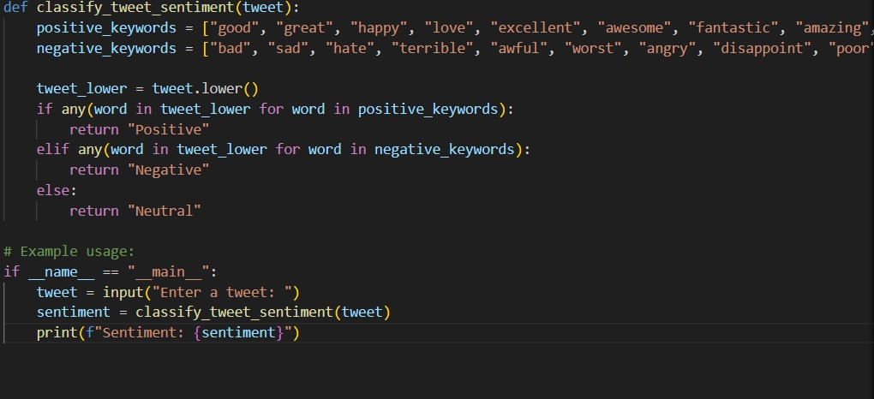

**Output:**

* 

**OBSERVATION:**

**Positive Sentiment Check**

* **The function looks for positive keywords like "good", "great", "happy", "love", "excellent", etc.**
* **If any of these words appear in the tweet (case-insensitive), the function returns "Positive".**
* **Negative Sentiment Check**
* **If no positive word is found, the function looks for negative keywords like "bad", "sad", "hate", "terrible", "awful", "worst", etc.**
* **If one of these words is present, it returns "Negative".**
* **Neutral Sentiment**
* **If the tweet does not contain any word from either list, it defaults to "Neutral".**

**TASK-2:**

**1.Prompt :**

**Write a Python program that takes a math problem as input (for example: "12 * 8") and outputs the solution.**

**Solve the problem step by step in code (e.g., parse the expression and evaluate it).**

**Make sure the program prints both the step-by-step explanation and the final answer.**

**CODE GENERATED:**

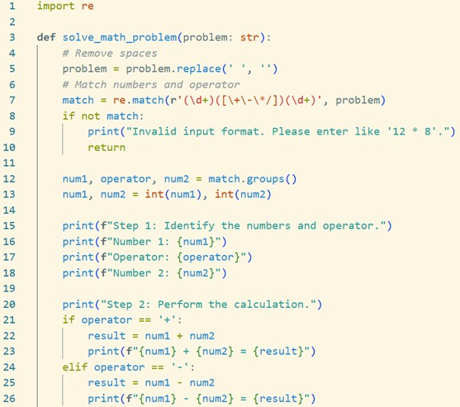

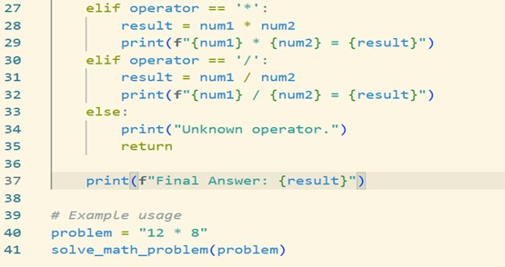

**Output:**

